CMPS 312 Mobile App Development
Assessment # 1
Student Name | Mohammad Ahmad
Student Id | 202002453
Email | ma2002453@qu.edu.qa
Grading Rubric - - In the Functionality column please specify either: Working (completed x%), Not Working (completed x%) or Not done.
Criteria | % | % Functionality | Instructor Feedback | Score
Q1.  - Book Class Implementation  - BooksRepo Class Implementation  - Extension Methods | 50% | 100% working | Excellent | 50
Q2 –  - Customer Class Implementation  - Account Class Implementation  - SavingsAccount and CurrentAccount Classes  - Mixin Implementation  - Taxable Interface | 50% | 100% working | Mixin not used as intended, -5 points | 45
Testing Sheet  Testing Sheet is Mandatory! Failure to submit the testing sheet along with your assignment will result in a 10% deduction from your total grade. Ensure that all required outputs are included in the testing sheet before submission. | -10
Total | 100 |  |  | 95
Copying and/or plagiarism or not being able to explain or answer questions about the implementation | -100
Possible grading for functionality:
- Complete and Working (get 70% of the assigned grade),
- Complete and Not working (lose 40% of assigned grade)
- Not done get 0.
- The remaining grade is assigned to the quality of the implementation.
- Must submit screenshots in this Testing-GradingSheet.docx (otherwise - 10pts).

- Q1 output
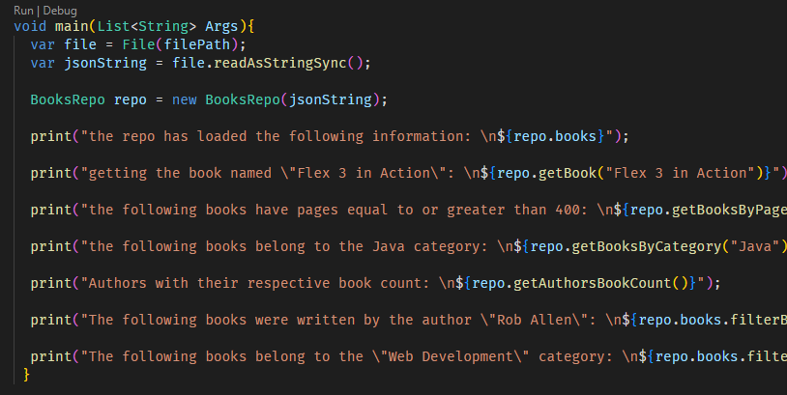
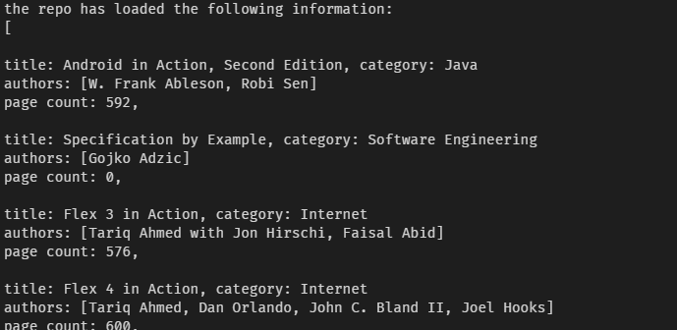
(goes on until all the books are listed)
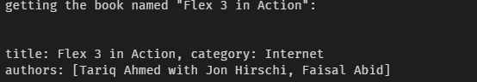
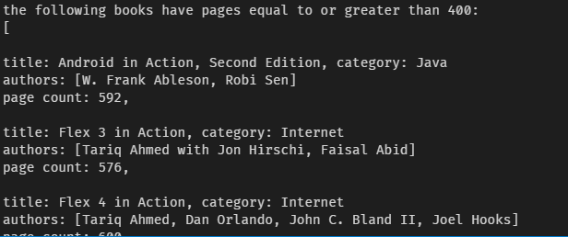
(list continues to show all books having page counts equal to or greater than 400)
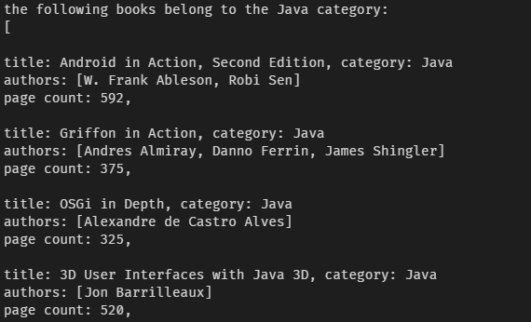
(list continues to show all books belonging to the Java category)
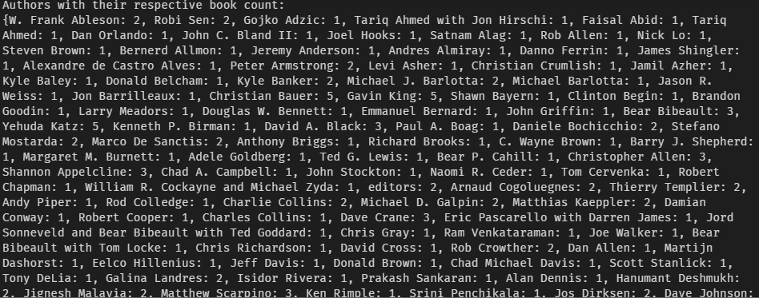
(continues to show all authors next to their book counts)
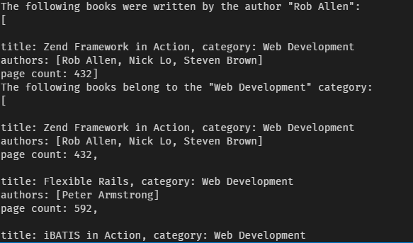
(continues to show all books that belong to the Web Development category)

- Q2 output
The output for each segment of code is attached right after it.
